**APP STORE OPTIMIZATION**

1A) App name: **Schoox** – an online learning platform

Category: E- Learning

1B) **Schoox** is a Social Learning Network and has a community open for anyone to join to be either a self-learner or an instructor or both and an enterprise module that can be used by corporations and organizations as their Training Academy.  As a member of Corporate Academy, user can attend online corporate courses, share content and knowledge, and collaborate with colleagues. A Self learner has access to many courses online from wide variety of domains just like Coursera.

Basically, the website is trying to get people to click on ads. This way they can do the publicity of their app and website. Also, they will ask users to subscribe to their email services through which users can be notified about upcoming new courses or the deadlines of the current courses.

1d) **Keywords**:

Online courses, Online Course website, E-learning website, best platform for online courses, Self paced course online, Business and Management Courses, Technology Courses, Personal Development Courses Online, free courses online, online school, Schoox learning platform,best online courses

**Long-tail Keywords**: Best platform for online courses, Self paced courses online, Personal Development Courses Online, Business and Management Courses.

**Head terms**: Online courses, online courses website, free courses online.

**Competitors ranks for keywords like**: Online Courses, free courses online, Management Courses,E-learning websites

**Reason for choosing the keywords**

The main reason behind choosing above keywords was they are relevant to the industry’s main goal and motive. To have a good ranking in google or any other search engine, the keywords should resemble the content and the goal of the website. As the app is the platform for online courses, all the keywords will be related to the online courses.

**How do you feel these keywords would help the business meet the goal you discovered, starting with downloads?**

All these keywords match the context and resemble the content of the website. If the website improves its ranking for those keywords, users will become aware of the new application named Schoox, which is a platform providing various online courses. As the website becomes more popular, the mobile application will also become popular in short period resulting in large number of downloads in the app store and google play store.

**How do you feel these keywords would help draw in organic traffic to the site?**

To generate organic traffic, the website’s content should match the keywords typed by user in search engine for finding the results. As the matching of website becomes increasingly relevant with the keywords, the organic traffic will increase as it is the traffic which comes on form the search engines.

**How well do you think the business can effectively compete for this keyword?**

All the keywords suggested above are related to company’s content and their business goals. As it is related to their business, implementing proper techniques for SEO in the company will help the business in ranking well ahead of its competitors.

2A)

For those particular keywords, the competitive apps like : Coursera, Udemy ,EdX and Udacity rank much higher compared to Schoox.

The major difference among these apps and Schoox is in the way these apps have targeted for specific keywords in their description also. They have repeatedly concentrated on the common keywords like: **online courses, best online courses, courses across different domains, free online courses** etc. They have used this keyword “**online courses**” in their title also. This enables them to rank higher for the common keywords related to e-learning websites. Moreover, in the google play store, all these apps have an overall rating around 4.5 out of 5. Many users have written a positive review about this business. The positive feedback from the users and high ratings in the app store is also a significant factor in higher ranking of these apps.

Schoox has rating of 3.4 in the play store and the number of downloads are also pretty less compared to the competitors.

**Patterns:**

Yes, these are the patterns regularly noticed among the competitors. It is due to this consistency that they are highly ranked among the others.

2b)

Group of Keywords: Online courses, best online courses, free online courses

Three other competitive apps which rank consistently well are**:**

**Coursera**, **Udemy** and **EdX**.

Attached below is the chart for all the 4 apps in three categories:

Time period for the below graphs is **Feb1,2016 to March 15,2017.**

1. **Visibility Score**

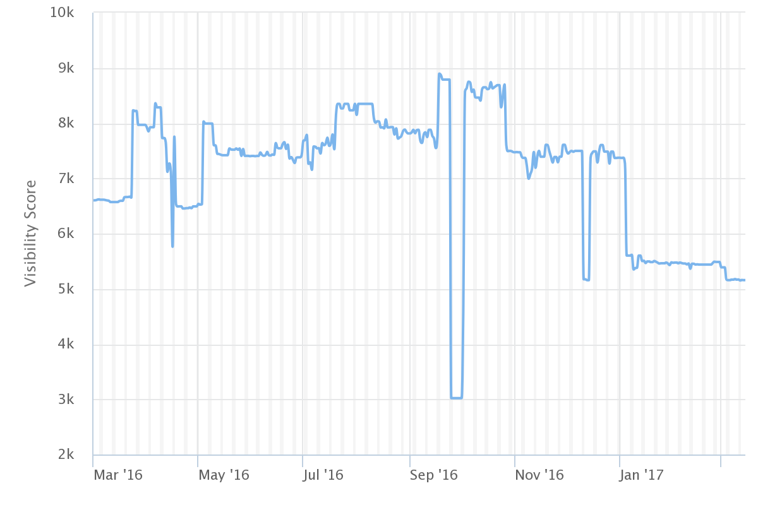**Visibility Score for Coursera**

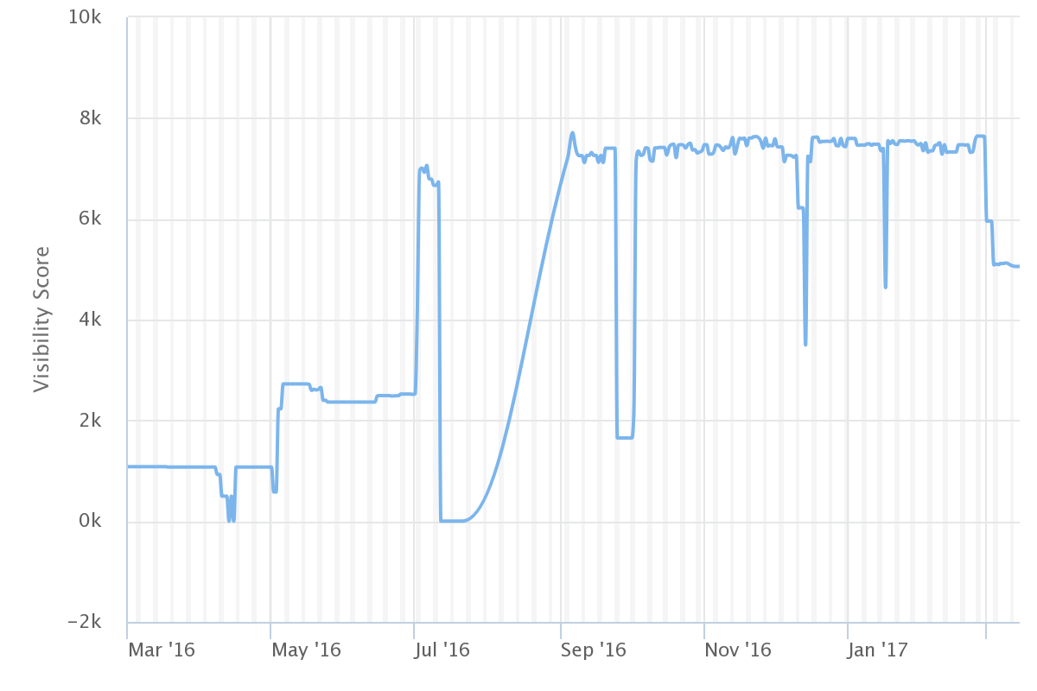**Visibility Score for Udemy**

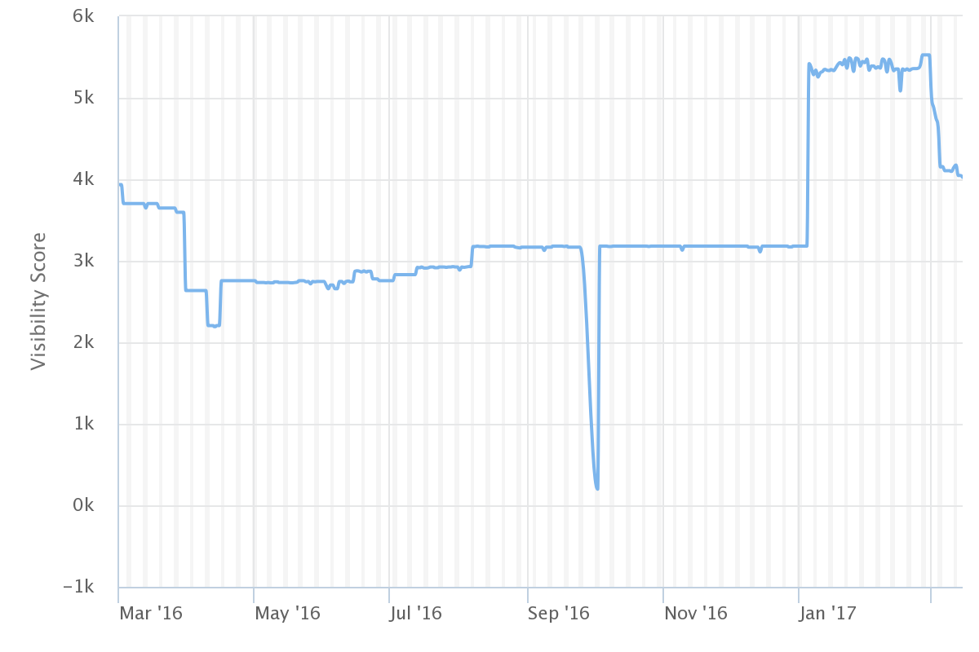**Visibility Score for EdX**

**Visibility Score for Schoox**

1. **Download volume and Velocity**

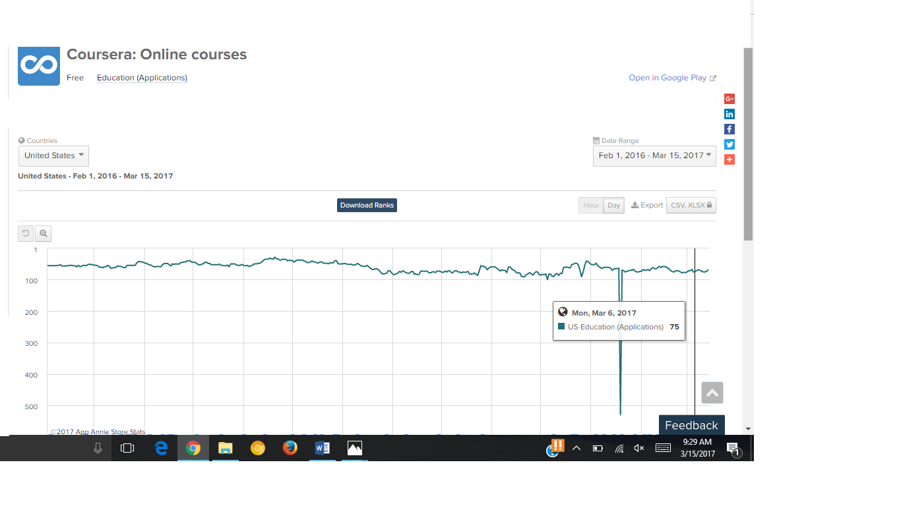**Coursera**

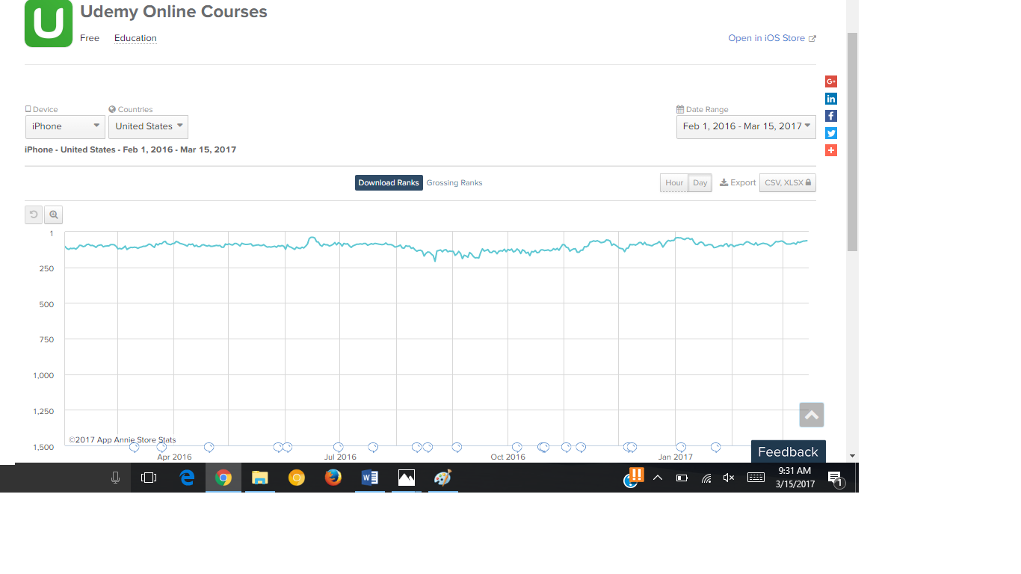**Udemy**

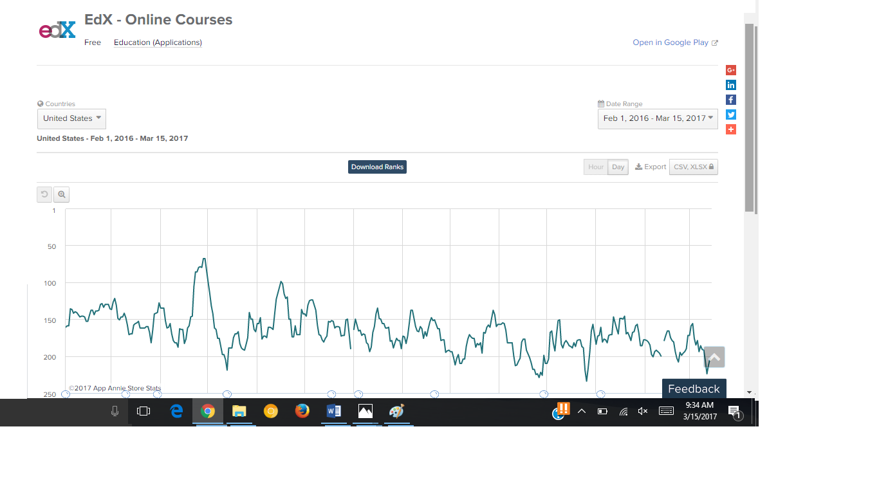**EdX**

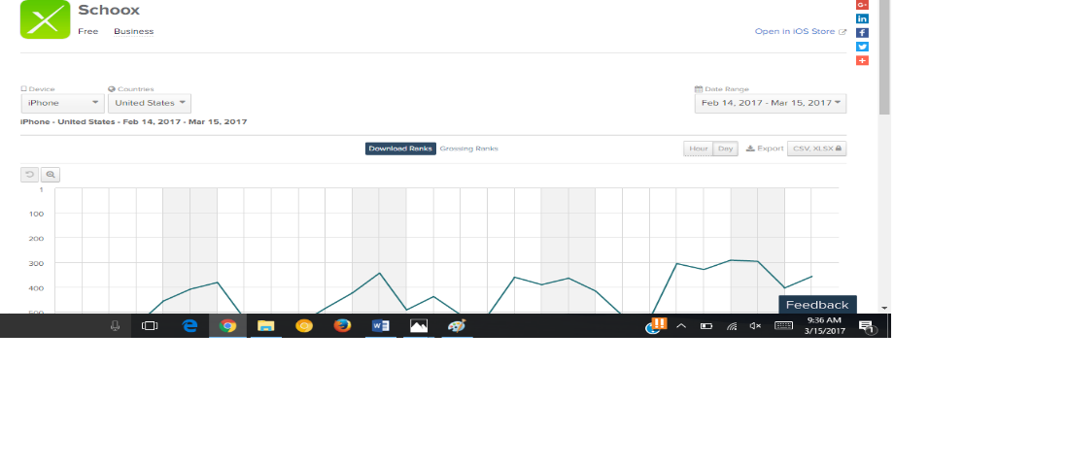**Schoox**

1. **Ratings and Reviews**

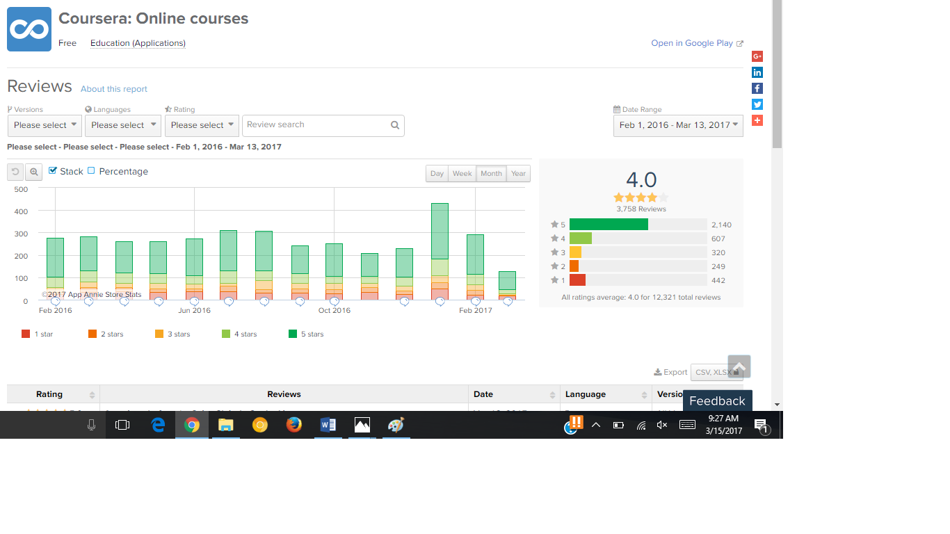**Coursera**

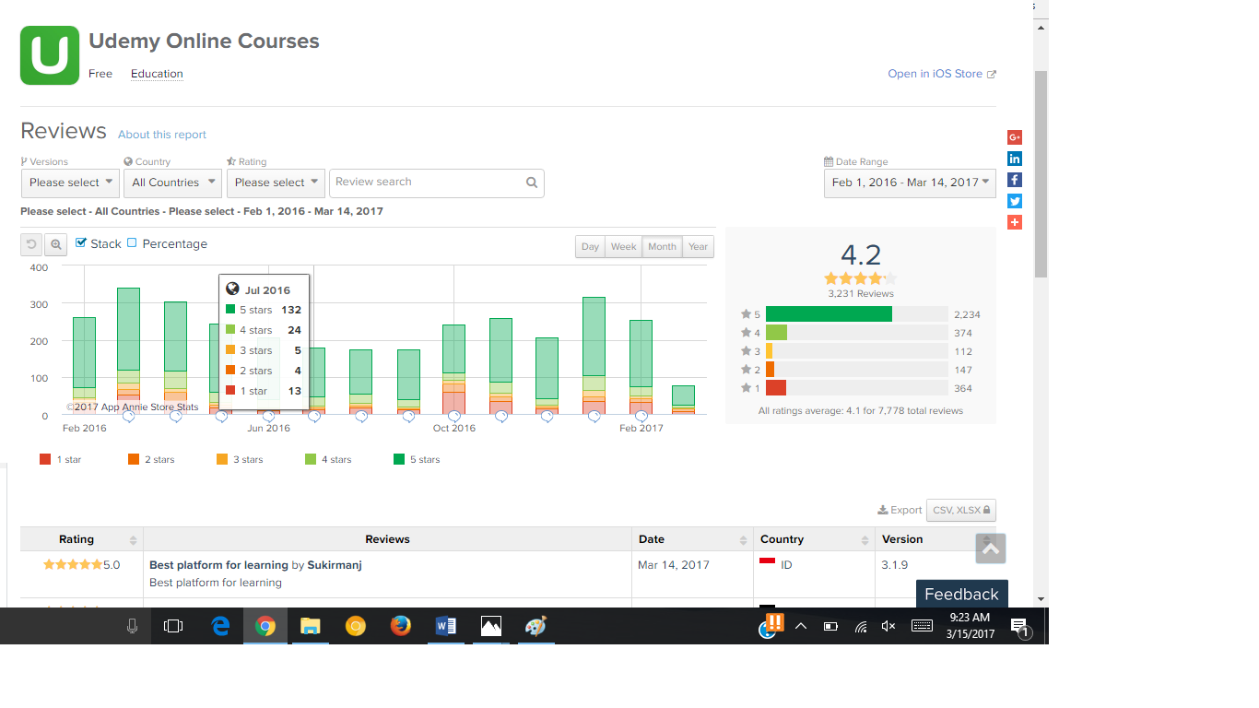**Udemy**

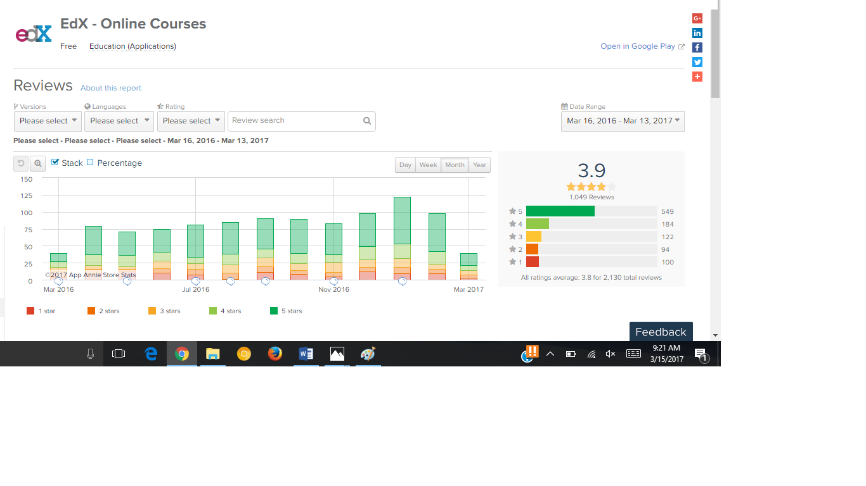**EdX**

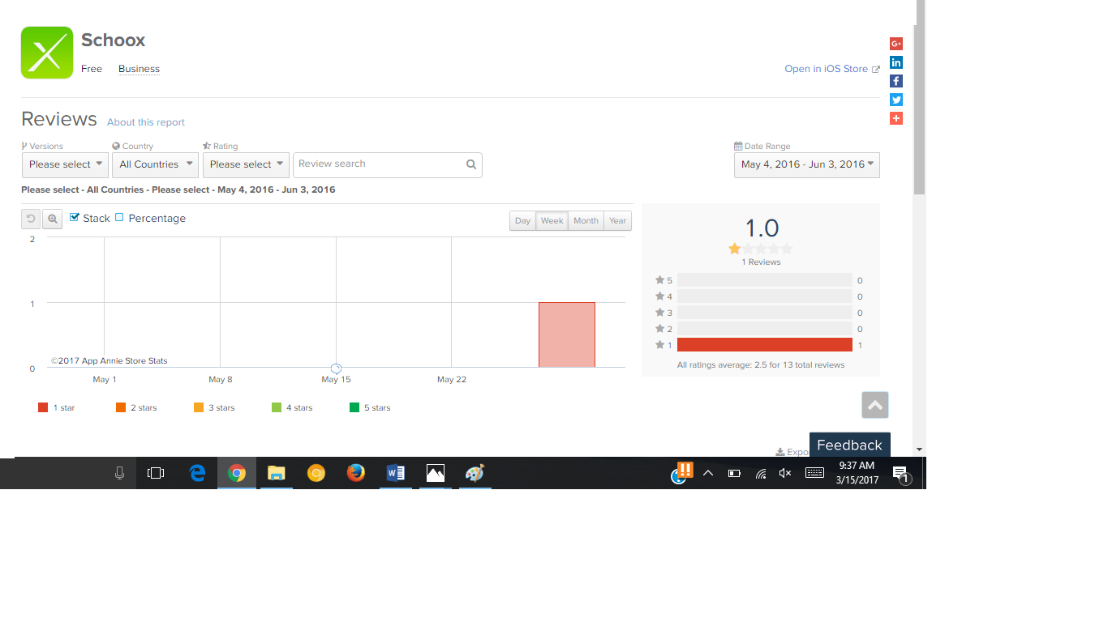**Schoox**

2C)

Schoox app needs to change their title tag and add one of the head keywords like: online courses, best online course platform, free online courses etc. This will lead to the higher ranking of this app. All the three platforms: Coursera, Udemy and EdX have taken this factor into consideration.

Coursera’s title is **Coursera: Online Courses.**

Udemy’s Title is **Udemy Online Courses.**

EdX’s title is **EdX – Online Courses.**

Also, Schoox app should use images which is about the online courses which they provide and which are very popular in today’s world. Through this, user will get to know that these courses are provided by Schoox and thus, will be interested in viewing it.

They can also ass the name of this courses or their brief title in the keywords for the App Search Optimization.

2D)

The common feature which I liked in all the three apps (Coursera, Udemy and EdX) is they provide an option for discovering the courses initially without logging in or registering the account. This feature is not available in Schoox and the user needs to register or login before viewing any courses. This is annoying for users as they need to create an account for viewing the courses.

One feature I liked about Schoox is the online corporate program where the user can attend online corporate courses, share content and knowledge, and collaborate with colleagues. This is a unique feature in this application which is absent in the other three.

Main dashboard page where all the courses are displayed is very attractive and appealing in the Coursera, Udemy and EdX application. In SchoolX application, it is very plain and simple which is not considered a good interface.

Moreover, the 3 apps have the feature of recommending courses also based on the previous courses selected. This is not visible in SchoolX application.

2E)

The competitive positioning of app is below average. For the hot keywords like: online courses, best online courses, free online courses etc. it is lagging far behind. Due to this, its user base is affected as many people are unaware about this application. Also, the people who have used this application are not very satisfied with this app.

**Observation without using tools**

App is ranked far below for the competitive keywords and the only way it appears in top results is through “brand name”.

The reviews provided by the user for the app are very unsatisfactory. The users are not happy with the interface and the way the app functions.

**Observation using tools**

The user must register or login in the app for viewing the courses. This is very annoying feature which needs to be updated. The basic functionality and the main goal of the application should be visible irrespective of whether the person is registered or not.

The concept of Schoox app is good. They are basically providing online courses to the users. Apart from that, they have a different section named Corporate Academy where user can attend online corporate courses, share content and knowledge, and collaborate with colleagues. This is a unique feature which I liked in the Schoox app.

**Key suggestions for improvement**

Targeting competitive keywords and long tail keywords will help this app in a long run.

It will improve its rankings exponentially. The title tags and the description should also consider targeting these keywords.

It has a unique feature of Corporate courses. So, besides targeting competitive keywords, it should also target unique keywords like: Corporate courses, online corporate courses etc. which will improve its rankings.

Should monitor the organic traffic and direct traffic on weekly basis. Compare the previous performance with the current performance to measure what went right or wrong for the increase or decrease in performance.

Target the famous websites with huge organic traffic for advertising the brand. This will also be a reasonable factor in improving the traffic.

Check the ratings and reviews provided by the user on a timely basis. Implement the feasible features recommended by the users as soon as possible for the user satisfaction.

2F)

First of all prioritize the recommendations after having team meeting.

The one thing which can be done is in the first week, work on keywords and the title improvements.

In the second week, the team can work on improving the description and targeting the keywords in the description.

In a month or two, the team can work on improving the features of the application and make it more user friendly. This will engage the users in the application.

After two months, they can review their app position through the keywords and also notice the ratings and reviews provided by the users. If the users are satisfied, then just concentrate on building and targeting the keywords but if they are still unsatisfied, more changes are required to be done in the application.